** **

***VOLUME 8 ISSUE 11 June 14, 2012***

**Grain Sorghum**

While a few of our sorghum fields were harvested this week, some fields have yet to head. We have found both stink bugs and corn earworms in sorghum fields from bloom to hard dough. Fields that have reached hard dough are relatively safe from stink bugs and headworms. Research trials have shown that stink bug and corn earworm control can be achieved by using the high rate of pyrethroids.

We have not seen many fall armyworms, but if they are found, the combination of Lannate and Dimethoate has shown to be effective.

Late planted sorghum fields that are still blooming should be monitored for sorghum midge. Midge populations have increased and may be at treatable levels.

**Table 1.** Average number of Rice Stink Bugs and Corn Earworms on 20 sorghum heads per plot of various insecticidal treatments. (Refugio County, 2012).

|  |  |  |  |  |  |  |  |  |  |  |  |  |  |  |  |
| --- | --- | --- | --- | --- | --- | --- | --- | --- | --- | --- | --- | --- | --- | --- | --- |
|  | | | | Rice stink bug | | | | | | Corn Earworm | | | | | |
|  | | | | Adult | | Nymph | | Mixed | | Medium Worms | | Large Worms | | Total Worms | |
|  | | | |  | |  | |  | |  | |  | |  | |
| 1 | Untreated Check |  |  | 1.3 | a | 0.3 | a | 1.5 | a | 3.5 | a | 5.8 | a | 9.3 | a |
| 2 | Dimethoate | 12 | oz/a | 0.3 | a | 0.0 | a | 0.3 | a | 2.8 | a | 8.3 | a | 11.0 | a |
| 3 | Dimethoate | 8 | oz/a | 0.0 | a | 0.0 | a | 0.0 | a | 0.3 | b | 0.3 | b | 0.5 | b |
|  | Lannate | 16 | oz/a |  |  |  |  |  |  |  |  |  |  |  |  |
| 4 | Karate | 3.84 | oz/a | 0.3 | a | 0.0 | a | 0.3 | a | 0.3 | b | 0.5 | b | 0.8 | b |
| 5 | Dimethoate | 8 | oz/a | 0.3 | a | 0.0 | a | 0.3 | a | 0.5 | b | 0.0 | b | 0.5 | b |
|  | Karate | 3.84 | oz/a |  |  |  |  |  |  |  |  |  |  |  |  |
| 6 | Endego | 4.5 | oz/a | 0.5 | a | 0.0 | a | 0.5 | a | 0.0 | b | 0.5 | b | 0.5 | b |
| 7 | Declare | 1.54 | oz/a | 1.0 | a | 0.0 | a | 1.0 | a | 0.8 | b | 0.0 | b | 0.8 | b |
|  | | | |  | |  | |  | |  | |  | |  | |
| LSD (P=.10) | | | | 0.92 | | 0.23 | | 0.96 | | 1.70 | | 3.04 | | 4.26 | |
| Standard Deviation | | | | 0.75 | | 0.19 | | 0.78 | | 1.39 | | 2.48 | | 3.47 | |
| CV | | | | 150.13 | | 529.15 | | 145.92 | | 121.51 | | 113.84 | | 104.57 | |
| Treatment Prob(F) | | | | 0.2409 | | 0.4552 | | 0.1493 | | 0.0100 | | 0.0004 | | 0.0005 | |

**Cotton **

Most if not all cotton fields are blooming and total nodes above white flower averages range from 9 to 2 NAWF. Blooming cotton should be inspected for Verde Plant Bug (*Creontiades*), Stink Bugs and Cotton Bollworms. Our surveys of cotton fields have found few stink bugs and verde plant bugs. When cutting bolls for evidence of feeding inspections, we have yet to find fields exceeding our economic threshold of 20%.

We have not found many bollworm eggs in cotton fields but continue to find cotton square borer eggs and larvae. Treatment for cotton square borer is rarely justified. Light numbers of aphids can be found in most cotton fields.

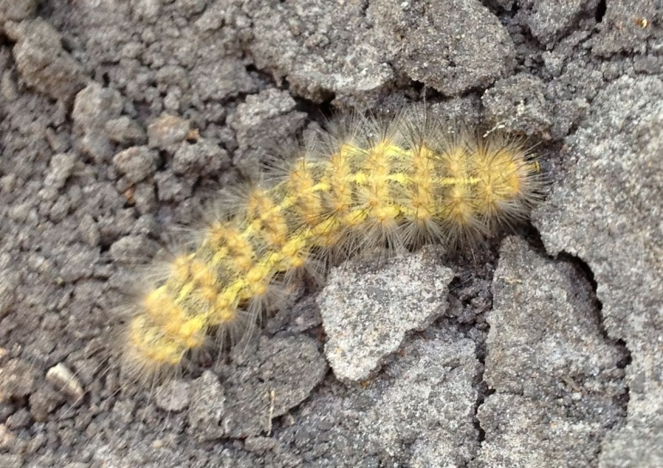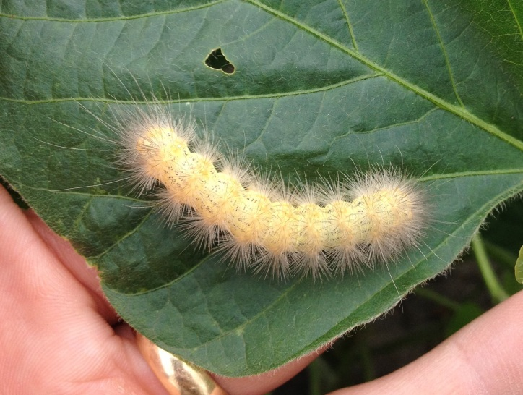Another insect we have been finding is the **Saltmarsh or Wollybear caterpillar**. These caterpillars will grow to a length of 2-2¼ inches long and have many whitish hairs covering the body. The larvae feed primarily on leaves and require high numbers to be yield limiting insects. While the female moth lays eggs in masses, we have not seen them in numbers greater than 1 in 10-20 plants.

** 2012 CROP TOUR SCHEDULE C:\Documents and Settings\AGNR\Local Settings\Temporary Internet Files\Content.IE5\HKNNUJN1\MC900037203[1].wmf**

**JUNE 19, 2012 CALHOUN COUNTY**

For information call 361-552-9747

**JUNE 20, 2012 VICTORIA COUNTY**

For information call 361-575-4581

Calhoun County will be offering Texas CCA CEU’s – 1.0 – Pest Management; .50 – Crop Management