What’s the Deal with Organic Food?

When it comes to food, the word organic can cause confusion. What does it mean and is it important for health?
The USDA has very specific requirements for foods that are labeled organic. Organic foods come from cattle or crops grown without antibiotics, most conventional pesticides, growth hormones, or bioengineering.
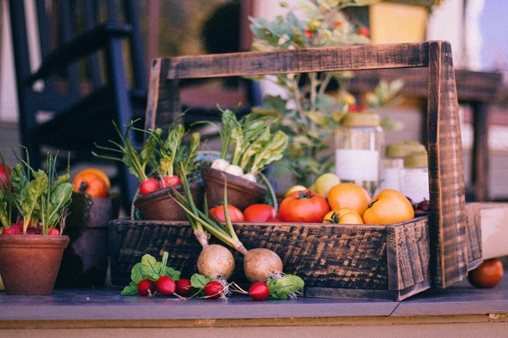
If you’re thinking “what do those words even mean?” don’t worry, for now the focus will just be pesticides.
Pesticides: Scary or Not?
Pesticides are any substances meant to kill insects or other organisms that are harmful to growing crops.
Organic crops use pesticides that are more natural/less toxic.
A common concern regarding conventional pesticides (not organic) is that crops grown with them may be harmful for people to consume. The Environmental Protection Agency (EPA) is responsible for ensuring that foods produced with pesticides are safe to eat.
Fruits and vegetables grown with pesticides may have pesticide residue on them but that does not mean they not safe to eat. The EPA works to make sure the amount of pesticide residue on foods is very, very, very small, so that it won’t come near to affecting health. The small amounts of pesticide residue are also decreased as food is harvested, transported, washed, prepared and cooked.
Research in this area is minimal, but for the most part, there is no clear evidence showing that foods grown with pesticides are harmful to health.
Nutrient Difference
Another common question is, are organic foods more nutritious? The short answer is, not really.
Some research shows that organic crops contain higher amounts of certain nutrients but, not by much. On the other hand, other research shows no difference in organic and inorganic foods. Keep in mind, packaged foods like, “organic” potato chips usually have just as much sodium and fat as non-organic potato chips.
One thing that is proven by research is that fruits and vegetables are important for good health. Most experts agree that people simply eating fruits and vegetables is more important than eating organic fruits and vegetables.
When you hear or read information about organic food always make sure it is from a reliable source.
Adapted from: www.epa.gov/safepestcontrol/food-and-pesticides and www.todaysdietitian.com/newarchives/040715p40.shtml
Photo Source: pixabay.com

Recipe of the Month
Source: foodhero.org
Treat your significant other, friends, family, or yourself to a tasty breakfast.
Banana Pancakes
Servings: 16 pancakes
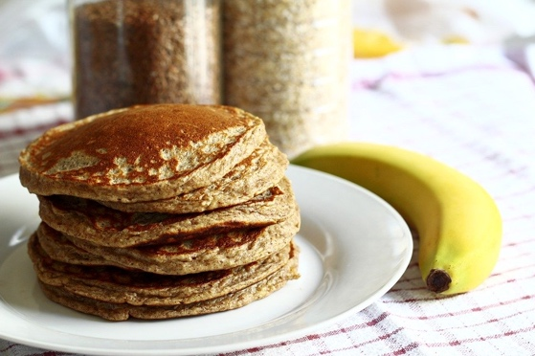
Ingredients
2 | eggs
1½ | cups low-fat milk
1 | tablespoon sugar
3 | tablespoons oil
2 | bananas, mashed
¾ | cup whole wheat flour
¾ | cup all-purpose flour
2 | teaspoons baking powder

Photo Source: pixabay.com

Directions
- Beat eggs in medium bowl. Add milk, sugar, oil and bananas and mix well. Add flours and baking powder. Mix gently.
- Lightly spray a large skillet or griddle with non-stick cooking spray or lightly wipe with oil. Heat skillet or griddle over medium-high heat (350 degrees in an electric skillet).
- Spoon 1/4 cup batter onto the griddle for each pancake. Cook until tops are bubbly and pancakes are dry around the edges. Flip and cook for 2-3 minutes or until golden brown.
- Refrigerate leftovers within 2 hours.

Tip: Top with sliced fruit, yogurt, or applesauce.

Nutrients Per Serving: (2 pancakes) 180 calories, 6 g total fat, 1 g saturated fat, 6 g protein, 26 g carbohydrates, 2 g dietary fiber, 7 g total sugars, and 150 mg sodium

